CounterPlay ’26 – Submission template
With this template, we invite you to share your play proposal for CounterPlay ’26, and we hope you will develop it in a playful spirit. While we welcome all sorts of contributions – play sessions, workshops, art performances, conversations, talks and formats we don’t know yet - we encourage you to consider how your session help us live more playful lives together.
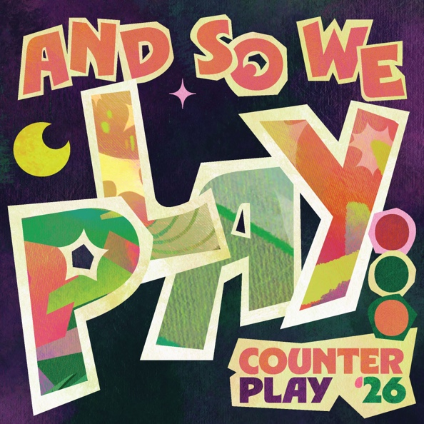
Submission deadline: January 5, 2026.
We will get back to you with our decision in the beginning of February, when we have had time to read and discuss all the proposals.
Submit by filling out this template (max 400 words) and uploading it via www.counterplay.org/submissions.
If you have problems or questions, contact Mathias Poulsen at mp@dskd.dk and/or Helle Marie Skovbjerg at hms@dskd.dk.
Your name(s) and institution(s) / place of work:

Email of primary contact person:

Title of submission:

Description of submission:

How does your proposal relate to our ‘call for play’?

What is it about play that you find most intriguing?

Do you have relevant links to your work?:

Do you have specific practical requirements?

